**实验一 Fragment 创建及生命周期**

1.编写一Android应用程序，自行创建两个fragment（内容自定），并观察fragment的各生命周期，界面运行截图自定，生命周期可参考如下：

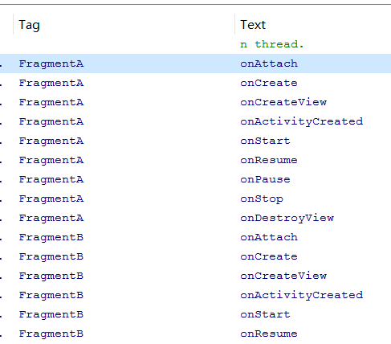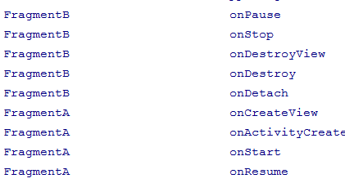

**结果运行如下：**

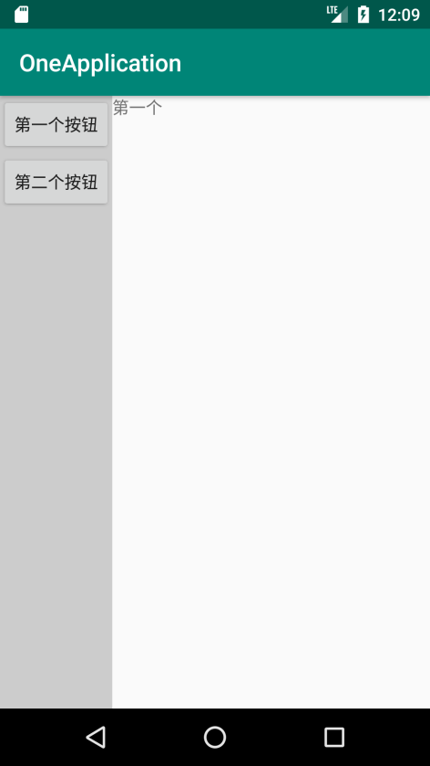 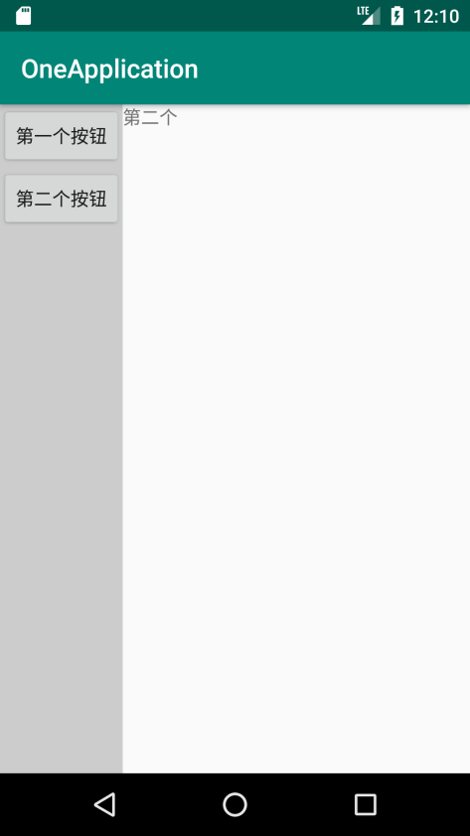

**生命周期截图如下：**

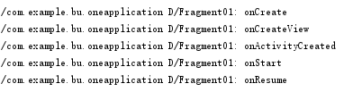

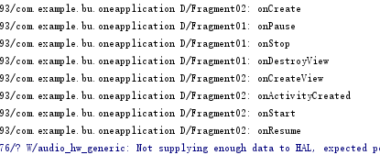

**MainActivity.java代码如下：**

**public class** MainActivity **extends** AppCompatActivity **implements** OnClickListener {  
 **private** FragmentManager **manager**;  
 **private** FragmentTransaction **transaction**;  
 **private** Button **button1**,**button2**;  
 @Override  
 **protected void** onCreate(Bundle savedInstanceState) {  
 **super**.onCreate(savedInstanceState);  
 setContentView(R.layout.***activity_main***);  
 **manager** = getFragmentManager();  
 **button1** = (Button)**this**.findViewById(R.id.***button1***);  
 **button1**.setOnClickListener(**this**);  
 **button2** = (Button)**this**.findViewById(R.id.***button2***);  
 **button2**.setOnClickListener(**this**);  
  
 }  
 @Override  
 **public boolean** onCreateOptionsMenu(Menu menu) {  
 *// Inflate the menu; this adds items to the action bar if it is present.* getMenuInflater().inflate(R.menu.***main***, menu);  
 **return true**;  
 }  
 *//通过点击不同的按钮，跳转到不同的Fragment* @Override  
 **public void** onClick(View v) {  
 *//* ***TODO Auto-generated method stub* transaction** = **manager**.beginTransaction();  
 **switch** (v.getId()) {  
 **case** R.id.***button1***:  
 Fragment01 fragment01 = **new** Fragment01();  
 **transaction**.replace(R.id.***right***, fragment01, **"fragment01"**);  
 **transaction**.addToBackStack(**"fragment01"**);*// 添加到Activity管理的回退栈中。* **break**;  
  
 **case** R.id.***button2***:  
 Fragment02 fragment02 = **new** Fragment02();  
 **transaction**.replace(R.id.***right***, fragment02, **"fragment02"**);  
 **transaction**.addToBackStack(**"fragment02"**);  
 **break**;  
 }  
 **transaction**.commit();  
 }  
}

**Fragment01.java代码如下：**

**（Fragment02.java与Fragment01基本一致）**

**public class** Fragment02 **extends** Fragment{  
 @Override  
 **public void** onCreate(Bundle savedInstanceState) {  
 **super**.onCreate(savedInstanceState);  
 }  
 @Override  
 **public** View onCreateView(LayoutInflater inflater, ViewGroup container,  
 Bundle savedInstanceState) {  
 View view = inflater.inflate(R.layout.***f1***, **null**);  
 **return** view;  
 }  
}

**如果要查看生命周期则Fragment01与Fragment02代码如下修改：**

**public class** Fragment01 **extends** Fragment{  
 **public static final** String ***TAG*** = **"Fragment01"**;  
 @Override  
 **public void** onCreate(Bundle savedInstanceState) {  
 **super**.onCreate(savedInstanceState);  
 Log.*d*(***TAG***,**"onCreate"**);  
 }  
 @Override  
 **public** View onCreateView(LayoutInflater inflater, ViewGroup container,  
 Bundle savedInstanceState) {  
 Log.*d*(***TAG***, **"onCreateView"**);  
 View view = inflater.inflate(R.layout.***f1***, **null**);  
 **return** view;  
 }  
 @Override  
 **public void** onActivityCreated(Bundle savedInstanceState) {  
 **super**.onActivityCreated(savedInstanceState);  
 Log.*d*(***TAG***, **"onActivityCreated"**);  
 }  
 @Override  
 **public void** onStart() {  
 **super**.onStart();  
 Log.*d*(***TAG***, **"onStart"**);  
 }  
 @Override  
 **public void** onResume() {  
 **super**.onResume();  
 Log.*d*(***TAG***, **"onResume"**);  
 }  
 @Override  
 **public void** onPause() {  
 **super**.onPause();  
 Log.*d*(***TAG***, **"onPause"**);  
 }  
 @Override  
 **public void** onStop() {  
 **super**.onStop();  
 Log.*d*(***TAG***, **"onStop"**);  
 }  
 @Override  
 **public void** onDestroyView() {  
 **super**.onDestroyView();  
 Log.*d*(***TAG***, **"onDestroyView"**);  
 }  
 @Override  
 **public void** onDestroy() {  
 **super**.onDestroy();  
 Log.*d*(***TAG***, **"onDestroy"**);  
 }  
 @Override  
 **public void** onDetach() {  
 **super**.onDetach();  
 Log.*d*(***TAG***, **"onDetach"**);  
 }  
}

**activity_main.xml代码如下：**

*<?***xml version="1.0" encoding="utf-8"***?>*<**LinearLayout xmlns:android="http://schemas.android.com/apk/res/android"  
 xmlns:app="http://schemas.android.com/apk/res-auto"  
 xmlns:tools="http://schemas.android.com/tools"  
 android:layout_width="match_parent"  
 android:layout_height="match_parent"  
 tools:context=".MainActivity"**>  
 <**LinearLayout  
 android:id="@+id/left"  
 android:layout_width="wrap_content"  
 android:layout_height="match_parent"  
 android:background="#CCCCCC"  
 android:orientation="vertical"** >  
 <**Button  
 android:id="@+id/button1"  
 android:layout_width="wrap_content"  
 android:layout_height="wrap_content"  
 android:text="第一个按钮"** />  
 <**Button  
 android:id="@+id/button2"  
 android:layout_width="wrap_content"  
 android:layout_height="wrap_content"  
 android:text="第二个按钮"** />  
 </**LinearLayout**>  
 <**LinearLayout  
 android:id="@+id/right"  
 android:layout_width="0dp"  
 android:layout_height="match_parent"  
 android:layout_weight="1"  
 android:orientation="vertical"** >  
 </**LinearLayout**>  
</**LinearLayout**>

**f1.xml代码如下：**

*<?***xml version="1.0" encoding="utf-8"***?>*<**LinearLayout  
 xmlns:android="http://schemas.android.com/apk/res/android" android:layout_width="match_parent"  
 android:layout_height="match_parent"  
 android:orientation="vertical"**>  
 <**TextView  
 android:id="@+id/textView1"  
 android:layout_width="wrap_content"  
 android:layout_height="wrap_content"  
 android:text="第一个"** />  
</**LinearLayout**>

**f2.xml代码如f1.xml一致稍加修改即可。**